**REVIEW TEST 4**

**VOCABULARY**

**Questions 1-6.** Complete the sentences below using play/go/do. Change the verb form if needed.

1. I ______play____ baseball with my friends on weekends.
2. They ____go______ swimming at the pool after school.
3. She _____plays_____ basketball at the local gym every Tuesday.
4. My parents ___do_______ exercise at the fitness center regularly.
5. He _____does_____ yoga in the morning for relaxation.
6. We ___go_______ cycling in the park on sunny days.

**Questions 7-10.** Look at the pictures and complete the sentences using given phrases. Change the verb form if needed.

|  |
| --- |
| get on get off get out of get in |

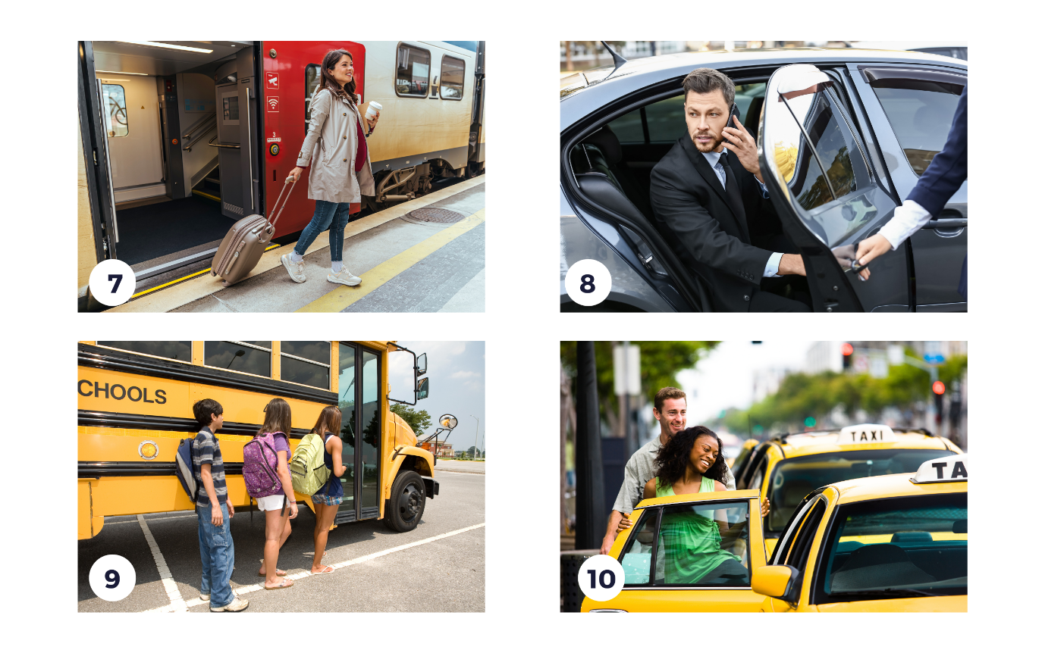

1. She __gets off________ the train at the main station every morning.
2. He ___gets out of_______ the car and walks to the store.
3. They _____get on_____ the bus at 8 AM to go to school.
4. We ___get in of_______ the taxi to go to the airport for our trip.

**Questions 11-15.** Choose correct words to complete the sentences.

**Tom:** Hi Sarah, what do you like to do in your free time?

**Sarah:** Hey, Tom! Well, I like to take **(11)** **(up)** new hobbies. Right now, I'm learning to play the guitar.

**Tom:** That sounds fun! I usually **(12)** **(surf)** the internet in my free time. I enjoy watching funny videos.

**Sarah:** Cool! Do you also get together **(13)** **(with)** friends often?

**Tom:** Yes, I do. We often eat **(14)** **(out)** at different restaurants on the weekends.

**Sarah:** Nice! I like doing that too sometimes. And do you work **(15)** **(out)** at the gym?

**Tom:** Yes, I try to work out at the gym a few times a week to stay healthy. How about you?

**Sarah:** I prefer outdoor activities, like hiking or biking. But I might give the gym a try someday.

**Tom:** Sounds great! It's good to stay active.

**Questions 16-18.** Answer these questions.

1. What sports do you play?

I go swimming

1. How do you go to work/school?

I go to work by motorbike

1. What do you do in your free time?

In my free time, I often listen to music and watch TV

**GRAMMAR**

**Questions 19-24.** Add -ed or -ing to the verbs in brackets to form adjectives and complete the sentences below.

1. The children are ___excited_______ about playing soccer in the park. (excite)
2. She is a talented musician, and her music is always __amazing________. (amaze)
3. I enjoy watching ___thrilling_______ movies on Friday nights. (thrill)
4. The __tired________ travelers are resting at the airport lounge. (tire)
5. The ____interesting______ book I'm reading keeps me engaged for hours. (interest)
6. We had a ___relaxing_______ day at the beach, swimming and sunbathing. (relax)

**Questions 25-30.** Are these sentences grammatically correct or incorrect? Put a (✓) if the sentence is correct and (🗶) if it is incorrect. Then, correct the mistakes.

1. She swims rapidly in the pool. 🞎

Correct

1. He drives the car slow through the narrow streets. 🞎

He drives the car slowly through the narrow streets

1. He is a skillfully tennis player at the club. 🞎

He is a skillful tennis player at the club

1. They perform a beautifully dance at the wedding. 🞎

They perform a beautiful dance at the wedding

1. I ride my bike careful in the park. 🞎

I ride my bike carefully in the park

1. The kids laugh loudly during their playtime. 🞎

Correct

**Questions 31-35.** Answer these questions. Use adverbs of frequency.

1. How often do you eat out?

I usually have lunch at a restaurant

1. How often do you go to concerts?

I never go to concerts

1. How often do you go hiking?

I seldom go hiking

1. How often do you work out at the gym?

I rarely work out at the gym

1. How often do you go to the cinema?

I sometimes go to the cinema

**PRONUNCIATION**

**Questions 36-40.** Track 4.1 Tick the words a) or b) that you hear in the sentences.

|  |  |  |  |
| --- | --- | --- | --- |
| 1. a) pig | 🞎 | b) big | 🞎 |
| 1. a) pack | 🞎 | b) back | 🞎 |
| 1. a) half | 🞎 | b) halve | 🞎 |
| 1. a) safe | 🞎 | b) save | 🞎 |
| 1. a) vet | 🞎 | b) wet | 🞎 |